

***Supporting higher education in Atlantic Canada for over 55 years***

**ANNUAL REPORT**

**2024-2025**

***April 1, 2024 - March 31, 2025***

MISSION

To ensure high quality Information and Communication Technology (ICT) services   
to all member institutions in New Brunswick and Prince Edward Island

VISION

To apply our collective skills and resources to the betterment   
of the New Brunswick and Prince Edward Island higher education communities   
through the deployment of state-of-the-art technology   
while saving money for our provinces and institutions

VALUES

**Honesty**

**Collaboration**

**Collegiality**

**Openness**

**Trust**

**Social Responsibility**

Visit our website at:

<http://www.nbpei-ecn.ca> (English)

<http://rie-nbipe.ca> (French)

NEW BRUNSWICK and PRINCE EDWARD ISLAND EDUCATIONAL COMPUTER NETWORK MEMBERS

|  |  |  |
| --- | --- | --- |
|  | **Collège communautaire du Nouveau-Brunswick** | |
| 725 College Street P.O. Box 266  Bathurst, New Brunswick E2A 3Z2 | Tel.: (506) 547-2063  Fax: (506) 547-2741  [www.ccnb.ca](http://www.ccnb.ca) |
|  | **Holland College** | |
| 140 Weymouth Street  Charlottetown, Prince Edward Island C1A 4Z1 | Tel.: (800) 446-5265  Fax: (902) 629-4239  [www.hollandcollege.com](http://www.hollandcollege.com) |
|  | **Maritime College of Forest Technology** | |
| 1350 Regent Street  Fredericton, New Brunswick E3C 2G6 | Tel.: (506) 458-0199  Fax: (506) 458-0652  [www.mcft.ca](http://www.mcft.ca/) |
|  | **Maritime Provinces Higher Education Commission** | |
| 82 Westmorland, Suite 401  P.O. Box 6000  Fredericton, New Brunswick E3B 5H1 | Tel.: (506) 453-2844  [www.mphec.ca](http://www.mphec.ca/) |
|  | **New Brunswick Community College** | |
| 284 Smythe Street  Fredericton, New Brunswick E3B 3C9 | Tel.: (506) 462-5012  Fax: (506) 462-5008  [www.nbcc.ca](http://www.hollandcollege.com) |
|  | **Mount Allison University** | |
| 155 Main Street  Sackville, New Brunswick E4L 1B5 | Tel.: (506) 364-2300  Fax: (506) 364-2299  [www.mta.ca](http://www.mta.ca/) |
|  | **St. Thomas University** | |
| 51 Dineen Drive  Fredericton, New Brunswick E3B 5G3 | Tel.: (506) 452-0640  Fax: (506) 450-9615  [www.stu.ca](http://www.stu.ca/) |
|  | **Université de Moncton** | |
| 18 Antonine-Maillet Avenue  Moncton, New Brunswick E1A 3E9 | Tel: (506) 858-4113  Fax: (506) 858-4544  [www.umoncton.ca](http://www.umoncton.ca/) |
|  | **University of New Brunswick** | |
| P.O. Box 4400  Fredericton, New Brunswick E3B 5A3 | Tel.: (506) 453-4573  Fax: (506) 453-5016  [www.unb.ca](http://www.unb.ca/) |
| http://files.upei.ca/communications/downloads/upei_logo_colour.jpg | **University of Prince Edward Island** | |
| 550 University Avenue  Charlottetown, Prince Edward Island C1A 4P3 | Tel.: (902) 566-0400  Fax: (902) 566-0420  [www.upei.ca](http://www.upei.ca/) |

Message from the Chair

On behalf of the NB/PEI Educational Computer Network, I am pleased to present our 2024-2025 Annual Report highlighting our activities and accomplishments over the past fiscal year. The ECN continues to exemplify effective collaboration for the benefits of its members while continuing to lead in Network and Communication Technology. This document highlights the ECN’s activities and accomplishments over the 2024-25 fiscal year.

I would like to begin by thanking Marc-André Arseneau (CCNB) for his role as Chair of the Network Committee this past year and to acknowledge the skilled and dedicated members of the Network Committee who generously provide expertise and guidance to achieve their mandate. I would also like to thank our respective provincial governments, fellow Board members, partners and stakeholders for their continuous support, hard work and dedication, which combined, has made this network successful for over 55 years.

The NB/PEI ECN continues to focus on successfully securing our members’ entire IT infrastructure, advancing cybersecurity tools and services to protect our institutions. The value from collaboration and cooperation among its members has contributed greatly to the ECN’s longevity and reputation across Canada. An Atlantic regional cooperation is being explored to expand and/or merge potential services to better serve the region’s needs.

I hope you will enjoy reading the following pages and learning about the many achievements of the ECN over the past year.

Dr. Alexander (Sandy) MacDonald



Chair, ECN Board of Directors

Table of Contents

Overview 1

More about ECN 1

ECN highlights for 2024-2025 include: 3

Governance (Board of Directors) 4

Network Committee 4

Designated installation 5

Meetings 5

Strategy 5

Communication and collaboration tools 5

Consortium Security 6

Network sustainability and improvement 6

Financial operations 6

Appendices 6

Appendix I: Members, Representatives, Alternates, and Chair 6

The Board members 6

The Network Committee Representatives and Alternates 7

The Chair of the Network Committee 7

The Network Sustainability Team 7

The ECN Communication Team 7

The Firewall Change Management Team 7

Appendix II: Research and Education Networks (REN) 8

New Brunswick Research and Education Network 8

Prince Edward Island Research and Education Network 10

Appendix III: ECN Service Areas / Projects 11

Appendix IV: Statements of Revenue and Expenditures 12

# Overview

The NB/PEI Educational Computer Network (ECN), founded in 1970, connects all of the universities, community colleges and the Maritime College of Forest Technology in New Brunswick (NB) and UPEI and Holland College in Prince Edward Island (PEI). The primary service provided by the network is connectivity among its members and to the wider world. Many additional benefits are enjoyed by members, notably joint purchasing and licensing, shared IT services, professional development, cyber security and the delivery of network-based services and information exchange.

This approach has enabled all ECN members to realize the benefits of a high capacity, high speed data communications network at a reasonable cost, regardless of size. It also allows members to take advantage of economies of scale not available to individual member institutions and ensures that smaller institutions receive the same level of service as larger ones. For several years, annual savings have averaged $1.5M. Through economies of scale, and with expertise contributed by all, ECN members pay less for many software applications, connections to commercial internet services, and equipment, than they could independently. Finally, members become stronger on the national front by providing a united voice with respect to the collective needs of New Brunswick and Prince Edward Island research and education sectors.

ECN is one of the oldest yet most innovative of the higher education IT consortia across Canada. ECN members benefit from a strong governance and management model, and a reasonably secure budget that ensures continuity and flexibility. ECN’s collaborative and collegial culture firmly supports its many accomplishments.

# More about ECN

Following a pilot project in the late 1960's, the NB Educational Computer Network was formed in 1970 when the New Brunswick Higher Education Commission, Mount Allison University, l’Université de Moncton, the University of New Brunswick, and St. Thomas University entered into an agreement to share computer-processing services. In 1974, the newly formed Maritime Provinces Higher Education Commission (MPHEC) assumed stewardship of the Agreement and in 1975, the University of Prince Edward Island joined as a full member, establishing the NB/PEI ECN. The signing of a five-year agreement, from May 1, 1992 to April 30, 1997, formalized the addition of Holland College as the next member of the group. A subsequent five-year agreement (May 1, 1997 to April 30, 2002) witnessed the addition of the Maritime Forest Ranger School (now the Maritime College of Forest Technology) to the list of member institutions of the ECN. The agreement (January 1, 2017 to March 31, 2022) witnessed the addition of the Collège communautaire de Nouveau Brunswick (CCNB) and the New Brunswick Community College (NBCC) to the list of member institutions. The current five-year agreement expires March 31, 2027.

The ECN is overseen by a Board of Directors, consisting of the Presidents of the member institutions and the Chief Executive Officer of the MPHEC. The overall management and operation of the network and the associated services is the responsibility of a Network Committee consisting of the Senior IT positions from each member institution. The ECN is funded by the Provinces of New Brunswick and Prince Edward Island, through the funding administered by the MPHEC, and is topped up with some direct funding from some of the institutions.

In addition to providing connectivity among its members, both NB and PEI portions of the network also connects member institutions to the wider world through a shared connection to the Canadian Advanced Research Network (CANARIE) and through CANARIE to the world. ECN has been highly successful in attracting capital investment from the federal government with over one million dollars contributed to the development and expansion of the NB and PEI research and education communications network and the Security Information and Event Management (SIEM) project. Inestimable value from collaboration, cooperation, and highly professional relationships among the members has contributed greatly to ECN’s reputation across Canada as having one of the best governances, management, and operating models among similar organizations.

Cyber security is one of the major risks that all ECN institutions face. Like other risks, this is an institutional risk and multiple stakeholders each have their own roles and responsibilities in the protection of sensitive data, finances and reputation of the organization.

Each organization is responsible for identifying, prioritizing and managing their own cyber security risks. Each respective IT Organization is typically responsible for the technology components which have been assigned through the cyber security risk management process. The ECN provides support and services to each member IT Organization, as per the initiatives collectively defined through the ECN Strategic Planning process – one being the cyber security initiative.

A successful cyber security strategy at any organization includes the articulation of clear accountabilities and structures (governance), as well as comprehensive strategies and frameworks that all stakeholders can use to collectively identify and mitigate cyber risk.

While the details may differ from ECN institution to institution, each respective IT Organization’s responsibility is to ensure that technology operations support the cyber security priorities as defined by the organization.

The ECN’s role is to support the individual and collective IT Organizations in their efforts to achieve those cyber security objectives.

### ECN highlights for 2024-2025 include:

The NB/PEI Educational Computer Network (ECN) continued to successfully provide connectivity among its members and to the wider world, just as it has for the past 55 years. These activities included:

* All ECN members are Resource Public Key Infrastructure (RPKI) compliant.
* Twelve router replacements took place without interruption.
* A secondary data center in Moncton was established.
  + Activated a second 100Gbps optical system
  + Relocated half of our network gear to the new site
  + Migrated half of the ECN fabric backbones to the second system
  + Introduced several additional 10Gbps backbones on the new system to enhance resiliency
* Established a second BGP peer between CCNET and ECN to further improve resiliency.
* Relocated the CANARIE connection from UPEI firewall to the PEI RAN and reconnected Holland College to the CANARIE network resulting in reduced operational costs and improved network resiliency for Holland College
* Retired the aging Ciena 5142 switches, which lowered maintenance costs for ECN and eliminated single points of failure.
* Extended the switch fabric to St. Andrews, simplifying the network and increasing the flexibility to support Layer 2 and Layer 3 connectivity at remote sites

In addition to the activities supporting the foundational network service, the following took place:

* Prepared a business case including a five-year funding model to address the additional costs for cybersecurity that was presented by the Board to the NB and PEI government.
* Initial discussions have taken place around the development of a formal Atlantic Region cooperative to share network resources and other shared services.
* Hosted a virtual ECN Technical Workshop in November 2024 that focused on Artificial Intelligence in Institutions, highlighting a presentation by Gillian Gray of McMaster University.
* QRadar Security Information and Event Management (SIEM) platform with Stratejm continued to successfully monitor logs after hours from ECN members.

# Governance (Board of Directors)

The ECN is governed by a Board of Directors (Board) consisting of the following members:

* The President of Holland College
* The Executive Director of the Maritime College of Forest Technology
* The Chief Executive Officer of the MPHEC
* The President of Mount Allison University
* The President of St. Thomas University
* Le recteur de l’Université de Moncton
* The President of the University of New Brunswick
* The President of the University of Prince Edward Island
* The President and CEO of the New Brunswick Community College
* Le président-directeur général du Collège communautaire du Nouveau-Brunswick

The Chairperson, whose term is five years, renewable for a second five-year term, is elected by the Board. Quorum is six members. Decisions must have the unanimous consent of those members voting (with the exception of a vote declaring that the service of the designated installation is inadequate; in which case the designated member is ineligible to vote). Generally, two meetings are held each year. The MPHEC performs administrative duties for the Board and manage the budget on behalf of all the members.

# Network Committee

The NB/PEI Educational Computer Network Committee (Network Committee) includes one voting representative nominated by each of the parties of the Agreement as well as a voting member who represents the Network Operations. An alternate representative to the Network Committee is also appointed. Members and alternates are appointed for an indefinite period or are replaced upon recommendation in writing to the Chairperson of the Board. The Chairperson of the Network Committee is nominated by the Network Committee, and is non-voting, and is approved by the Board for a maximum of two 2-year terms. The Chairperson may also be a voting member if they are the representative nominated by the member institution or the network operations representative. The MPHEC representative is the Secretary of the Network Committee. The Network Committee meets 5-6 times annually. The duties of the Network Committee are listed in Appendix A of the ECN Agreement. The Network Committee makes decisions by unanimous consent of members voting.

The Network Committee submits, on or before March 15th, a recommended Network Plan and Budget to the Vice-President (Finance) of each of the member institutions for confirmation. Once confirmed, the Network Committee submits the Network Plan and Budget to the Board for approval. At the end of the year, the Committee drafts an annual report for approval by the Board showing its performance compared to the Network Plan from the beginning of the fiscal year.

# Designated installation

UNB is the designated, and the major, installation for the Network. Computing facilities and Information and Communication Technology (ICT) services are provided by UNB to all ECN members as detailed in Appendices B and C of the ECN Agreement.

# Meetings

The ECN Network Committee met five times in 2024-2025:

May 8, 2024 Climate Change Center St. Peter’s Bay, PEI

July 17, 2024 Virtual meeting

September 11, 2024 Virtual meeting

September 25, 2024 Virtual meeting

March 18, 2025 Virtual meeting

A list of the Board and Network Committee members is included in Appendix I.

Appendix II includes:

* A New Brunswick map displaying the physical network connections and their relative bandwidth as well as CANARIE links.
* A New Brunswick map displaying the connected campuses of the partner institutions; there are a total of 36 campuses connected in 15 cities, towns, and villages.
* The Prince Edward Island map shows the connected locations and the CANARIE link.

# Strategy

The key shared service of the ECN is connecting member institutions via a high-speed, high-capacity research and education network. Members also jointly purchase and deploy IT products and services such as anti-virus software, Office 365, firewalls and security and event management being some examples of successful collaborations.

The next five year strategy will be developed in the 2025-2026 period but will be heavily dependent on discussions happening at the national level around cybersecurity, so may be delayed.

ECN updated its strategic plan to focus on the following areas for an interim period:

Communication and collaboration tools: The Teams Telephony project has significantly reduced the cost of participating institutions for telephone services. A new RFP will determine the next vendor to host this service and will remove the requirement for hardware hosted at UNB, potentially reducing the cost of the service further and allowing for easier billing to the institutions.

Consortium Security: Security remains a top priority for ECN. Stratejm, an Ontario-based company, is providing after business hours SIEM monitoring and it will be considered whether this can move to 24x7 monitoring. ECN members will engage with a national effort to improve cybersecurity posture of Canadian higher education in general and will determine what that means for the ECN’s 2026-2027 roadmap.

Network sustainability and improvement ECN has prioritized the development and enhancement of the network, expanding its reach as necessary and reinforcing its resiliency and redundancy whenever possible.

A table of strategic objectives is in Appendix III.

# Financial operations

A copy of the approved budget vs actual expenditures for 2024-2025 as well as the balance of the ECN committed funds as of March 31, 2025, is included in Appendix IV. New Brunswick’s balanced budget used the remaining balance of the reserve funds. Internet Access was lower than budgeted for both NB and PEI. Hardware, software and maintenance were below budget for the year. The CAF membership remains stable with no increase. Meetings and training expenditures were lower due to fewer in-person meetings and a virtual workshop. The Network Operation core costs were lower due to lower maintenance cost on Network upgrades. The NB GigaPOP was as budgeted. The ECN’s accumulated surplus of $204,193 (NB: $0; PEI: $204,193) will be used to assist in funding cybersecurity initiatives and SIEM upgrading. The ECN Committee will be considering how to best leverage our resources for cost savings moving forward and determining the budget line items and the use of our committed funds carefully until future opportunities can be identified that will be available to ECN to alleviate some of these costs. The Network Committee will be developing a new three-year Strategic Plan that will include a sustainable funding model for the ECN.

# Appendices

## Appendix I: Members, Representatives, Alternates, and Chair

The Board members as of March 31, 2025 were:

|  |  |
| --- | --- |
| **Institution** | **Representative** |
| * Mount Allison University | Dr. Ian Sutherland |
| * St. Thomas University | Dr. M. Nauman Farooqi |
| * Université de Moncton | Dr. Denis Prud’homme |
| * University of New Brunswick | Dr. Paul Mazerolle |
| * University of Prince Edward Island | Dr. Wendy Rodgers |
| * Holland College | Dr. Alexander MacDonald (Chair) |
| * Maritime College of Forest Technology | Mr. Michel LeBlanc |
| * Maritime Provinces Higher Education Commission | Ms. Catherine Stewart |
| * Collège communautaire du Nouveau-Brunswick | M. Pierre Zundel |
| * New Brunswick Community College | Ms. Mary Butler |

The Network Committee Representatives and Alternates as of March 31, 2025 were:

|  |  |  |
| --- | --- | --- |
| **Institution** | **Representative** | **Alternate** |
| * Mount Allison University | Mr. John Gillis | Mr. Peter Crawshaw |
| * St. Thomas University | Vacant | Mr. Robert Brewer |
| * Université de Moncton | M. André Lee | Ms. Maryse Haché |
| * University of New Brunswick | Mr. Mark Humphries | Mr. Dave Totton |
| * New Brunswick Network | Mr. Ying Zhang | Mr. Chris Miller |
| * University of Prince Edward Island | Mr. Dana Sanderson | Mr. Rob Milman |
| * Holland College | Mr. Jacob Gallant | Mr. Greg Mermuys |
| * Maritime College of Forest Technology | Mr. Chris Finnamore | Mr. Bob Ross |
| * Maritime Provinces Higher Education Commission | Ms. Rachael Anderson | Mr. Scott Stonehouse |
| * Collège communautaire du Nouveau-Brunswick | Mr. Tony Roy | Mr. Marc-André Arseneau |
| * New Brunswick Community College | Mr. Simon Collier | Mr. Blair Sawler |

The Chair of the Network Committee was Marc-André Arseneau.

Other ECN committees include:

The Network Sustainability Team

The ECN Communication Team

The Firewall Change Management Team

## Appendix II: Research and Education Networks (REN)

### New Brunswick Research and Education Network

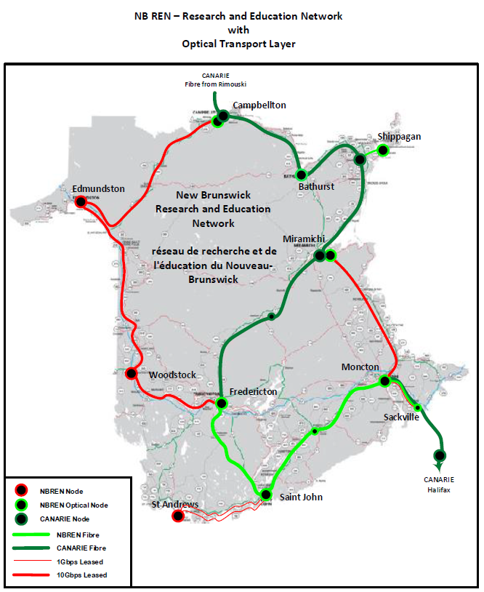

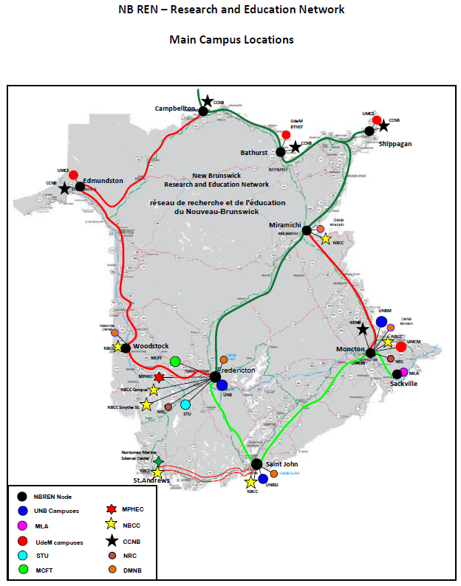

### Prince Edward Island Research and Education Network

## Appendix III: ECN Service Areas / Projects

|  |  |  |  |
| --- | --- | --- | --- |
|  | **Objectives**  **2024** | **Objectives**  **2025** | **Objectives**  **2026** |
| **Connectivity** | * Explore RPKI | * Network Equipment needs * Several firewalls will be replaced including the main gateway firewall for Moncton ISP and the backup CANARIE link as well as the firewalls at UNBSJ | * Continue enhancing and finalizing the resiliency of local campus connections to the ECN * Ensure the ongoing renewal and lifecycle management of primary network infrastructure |
| **Shared Services** | * SIEM monitoring expansion to 24/7 * Extending SIEM and Stratejm to other Maritime institutions | * SIEM monitoring expansion to 24/7 * Extending SIEM and Stratejm to other Maritime institutions | * SIEM Monitoring expansion to 24/7 * Extending SIEM and Stratejm to other Maritime institutions |
| **Joint Purchasing** | * Explore Microsoft A5 licensing prospects * Continue Canadian Access Federation (CAF) membership | * Procurment review * Continue Canadian Access Federation (CAF) membership | * Procurement review * Continue Canadian Access Federation (CAF) membership |
| **Professional Development** | * ECN workshop * Canheit | * ECN workshop * Canheit | * AUCTC * ECN workshop * Canheit |
| **National Representation and Sharing of Information and Best Practices** | * NREN GC * Alliance | * NREN GC * Alliance | * NREN GC * Alliance |
| **Organizational** | * Strategic Plan renewal * Explore collaborative links with Atlantic region RANs * Secure funding model | * Strategic Plan renewal * Explore collaborative links with Atlantic region RANs * Developing an inventory of institutional applications across the ECN | * Interim 12–18-month roadmap * Strategic Plan renewal * Agreement update * Atlantic collaboration |

## Appendix IV: Statements of Revenue and Expenditures

|  |  |  |  |  |  |
| --- | --- | --- | --- | --- | --- |
| **EDUCATIONAL COMPUTER NETWORK NEW BRUNSWICK AND PRINCE EDWARD ISLAND STATEMENT OF REVENUE AND EXPENDITURES\*** | | | | | |
| **PERIOD ENDED: 3/31/2025** | | **Budget** | |  | **Actual** | |
| **Account Description** | | **2024-2025** | |  | **2024-2025** | |
|  | |  | |  |  | |
| **Revenue** | |  | |  |  | |
| Provincial Transfers | | 946,538 | |  | 1,036,338 | |
| Direct Funding from institutions | | 504,476 | |  | 504,476 | |
| External fees for service | | 53,269 | |  | 0 | |
| Committed funds | | 64,280 | |  | 14,280 | |
| **Total Revenue** | | **1,568,563** | |  | **1,555,094** | |
|  | |  | |  |  | |
| **Expenditures** | |  | |  |  | |
|  | |  | |  |  | |
| **Network Shared Services** | |  | |  |  | |
| UNB as the designated installation (service provider) | | 245,858 | |  | 245,859 | |
| **Total Network Shared Services** | | 245,858 | |  | 245,859 | |
|  | |  | |  |  | |
| **Telecommunications** | |  | |  |  | |
| PEI Provincial Lines & Internet Access | | 30,000 | |  | 13,068 | |
| NB Internet Access | | 60,000 | |  | 50,103 | |
| **Total Telecommunications** | | 90,000 | |  | 63,171 | |
|  | |  | |  |  | |
| **Hardware, software, maintenance** | |  | |  |  | |
| Hardware | | 11,118 | |  | 148 | |
| Software | | 9,644 | |  | 8,251 | |
| CAF Maintenance | | 24,100 | |  | 24,100 | |
| Maintenance | | 134,849 | |  | 123,782 | |
| **Total Hardware, Software, Maintenance** | | 179,711 | |  | 156,281 | |
|  | |  | |  |  | |
| **Meetings and Collaboration** | |  | |  |  | |
| Network Committee | | 12,000 | |  | 5,523 | |
| Collaborative Projects | | 101,540 | |  | 64,818 | |
| RAN contributions to SIEM Initiative | | 30,000 | |  | 25,876 | |
| SIEM Afterhours | | 353,372 | |  | 381,150 | |
| ECN SharePoint Services | | 0 | |  | 839 | |
| **Total Meetings and Collaboration** | | 496,912 | |  | 478,206 | |
|  | |  | |  |  | |
| **NBREN and GigaPOP** | |  | |  |  | |
| NBREN CORE | | 510,313 | |  | 488,364 | |
| NBREN Additional Connections | | 20,769 | |  | 0 | |
| NB GigaPOP Services | | 25,000 | |  | 25,000 | |
| **Total NBREN and GigaPOP** | | 556,082 | |  | 513,364 | |
|  | |  | |  |  | |
| **Total Expenditures** | | **1,568,563** | |  | **1,456,881** | |
|  | |  | |  |  | |
| **Net revenue (net loss)** | | ***0*** | |  | ***98,213*** | |
|  | |  | |  |  | |
| **NB & PEI Committed Funds Balance as at March 31, 2025:** | |  | |  |  | |
| Balance, April 1, 2024 | |  | |  | 120,260 | |
| Net revenue (loss) for the year | |  | |  | 83,933 | |
| **Balance, March 31, 2025**  *as per MPHEC audited financial statements | |  | |  | **204,193** | |
| **EDUCATIONAL COMPUTER NETWORK**  **NEW BRUNSWICK**  **STATEMENT OF REVENUE AND EXPENDITURES\*** | | | | |
| **PERIOD ENDED: 3/31/2025** | | | | |
|  | | **Budget** |  | **Actual** | |
| **Account Description** | | |  | | --- | | **2024-2025** |   **20242023** |  | **2024-2025** | |
|  | |  |  |  | |
| **Revenue** | |  |  |  | |
| Provincial Transfers | | 860,938 |  | 860,938 | |
| Direct contributions | | 328,000 |  | 328,000 | |
| External Fees for Service | | 53,269 |  | 0 | |
| UNB Network Fund | | 150,000 |  | 150,000 | |
| Committed Funds | | 14,280 |  | 14,280 | |
| **Total Revenue** | | **1,406,487** |  | **1,353,218** | |
|  | |  |  |  | |
| **Expenditures** | |  |  |  | |
|  | |  |  |  | |
| **Network Shared Services** | |  |  |  | |
| UNB as the designated installation (service provider) | | 233,566 |  | 233,566 | |
| **Total Network Shared Services** | | 233,566 |  | 233,566 | |
|  | |  |  |  | |
| **Telecommunications** | |  |  |  | |
| Internet Access | | 60,000 |  | 50,103 | |
| **Total Telecommunications** | | 60,000 |  | 50,103 | |
|  | |  |  |  | |
| **Hardware, software, maintenance** | |  |  |  | |
| Hardware | | 11,118 |  | 148 | |
| Software | | 8,800 |  | 7,495 | |
| CAF membership | | 18,700 |  | 18,700 | |
| Maintenance | | 124,849 |  | 115,013 | |
| **Total Hardware, software, maintenance** | | 163,467 |  | 141,356 | |
|  | |  |  |  | |
| **Meetings and Collaboration** | |  |  |  | |
| Network Committee | | 10,000 |  | 5,040 | |
| Collaborative Projects | | 0 |  | 1,924 | |
| RAN contribution to SIEM initiative | | 30,000 |  | 25,876 | |
| SIEM Afterhours monitoring | | 353,372 |  | 381,150 | |
| SharePoint Services | | 0 |  | 839 | |
| **Total Meetings and Collaboration** | | 393,372 |  | 414,829 | |
|  | |  |  |  | |
| **NBREN and GigaPOP** | |  |  |  | |
| NBREN CORE | | 510,313 |  | 488,364 | |
| NBREN Additional Connections | | 20,769 |  | 0 | |
| NB GigaPOP Services | | 25,000 |  | 25,000 | |
| **Total NBREN and GigaPOP** | | 556,082 |  | 513,364 | |
|  | |  |  |  | |
| **Total Expenditures** | | ***1,406,487*** |  | ***1,353,218*** | |
|  | |  |  |  | |
| **Net revenue (net loss)** | | ***0*** |  | ***0*** | |
|  | |  |  |  | |
| **NB Committed Funds Balance as at March 31, 2025:** | |  |  |  | |
| Balance, April 1, 2024 | |  |  | 14,280 | |
| Net revenue (loss) for the year | |  |  | -14,280 | |
| **Balance, March 31, 2025** | |  |  | **0** | |

*as per MPHEC audited financial statements

|  |  |  |  |
| --- | --- | --- | --- |
| **EDUCATIONAL COMPUTER NETWORK  PRINCE EDWARD ISLAND**  **STATEMENT OF REVENUE AND EXPENDITURES\*** | | | |
| **PERIOD ENDED: 3/31/2025** | | | |
|  | **Budget** |  | **Actual** |
| **Account Description** | **2024-2025** |  | **2024-2025** |
|  |  |  |  |
| **Revenue** |  |  |  |
| Provincial Transfers | 85,600 |  | 175,400 |
| Direct HC/UPEI Transfer | 26,476 |  | 26,476 |
| Committed funds | 50,000 |  |  |
| **Total Revenue** | **162,076** |  | **201,876** |
|  |  |  |  |
| **Expenditures** |  |  |  |
|  |  |  |  |
| **Network Shared Services** |  |  |  |
| UNB as the designated installation (service provider) | 12,292 |  | 12,293 |
| **Total Network Shared Services** | 12,292 |  | 12,293 |
|  |  |  |  |
| **Telecommunications** |  |  |  |
| Provincial Lines & Internet Access | 30,000 |  | 13,068 |
| **Total Telecommunications** | 30,000 |  | 13,068 |
|  |  |  |  |
| **Hardware, software, maintenance** |  |  |  |
| Hardware | 0 |  | 0 |
| Software | 844 |  | 756 |
| CAF Maintenance | 5,400 |  | 5,400 |
| Maintenance | 10,000 |  | 8,769 |
| **Total Hardware, software, maintenance** | 16,244 |  | 14,925 |
|  |  |  |  |
| **Meetings and Collaboration** |  |  |  |
| Network Committee | 2,000 |  | 483 |
| Collaborative Projects | 101,540 |  | 62,894 |
| **Total Meetings and Collaboration** | 103,540 |  | 63,377 |
|  |  |  |  |
| **Total Expenditures** | **162,076** |  | **103,663** |
|  |  |  |  |
| **Net revenue (net loss)** | ***0*** |  | ***98,213*** |
|  |  |  |  |
| **PEI Committed Funds Balance as at March 31, 2025:** |  |  |  |
| Balance, April 1, 2024 |  |  | 105,980 |
| Net revenue (loss) for the year |  |  | 98,213 |
| **Balance, March 31, 2025** |  |  | **204,193** |

*as per MPHEC audited financial statements